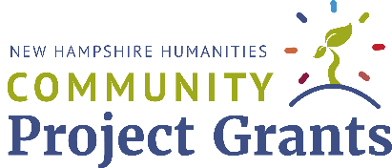

Project Narrative

Project Title: Click or tap here to enter text.
Applicant Organization: Click or tap here to enter text.
Project Director: Click or tap here to enter text.
Subject Matter Expert: Click or tap here to enter text.
Amount Requested from NHH: $Click or tap here to enter text.

OVERVIEW
Project Description
Briefly summarize your proposed project.
Click or tap here to enter text.

Engagement with the Humanities

Indicate which humanities field(s) your project engages (check all that apply).
History | ☐ | Literature | ☐ | Philosophy | ☐
Ethics | ☐ | Archeology | ☐ | Anthropology | ☐
Geography | ☐ | Language & Linguistics | ☐ | Law, Legal History or Theory | ☐
Religious Studies | ☐ | Art Criticism | ☐ | Other | ☐

Explain how your project will draw on these field(s) or will otherwise deploy a humanistic or interpretive framework to explore a topic.
Click or tap here to enter text.

Project Format
In as much detail as possible, explain your project, program, or series. What are its main events/components and how will these be structured/organized? Please indicate whether any dates, speakers, or locations are anticipated/confirmed.
Click or tap here to enter text.

Project Significance
How will your project contribute to NH residents’ understanding or knowledge of a particular issue, topic of debate, or subject?
Click or tap here to enter text.

Audience Engagement
Identify your target audience and indicate how many people you expect to attend. Then explain why your project will interest them and how they will participate in the program or event.
Click or tap here to enter text.

Evaluation
How will you assess the impact of your program? Identify one method you will use and briefly explain what information you hope to gain through this method.
Click or tap here to enter text.

PLANNING AND TIMELINE

Role of the Subject Matter Expert
Summarize your Subject Matter Expert’s expertise -- their knowledge of a particular humanities field -- and explain what role they will play in the project’s development.
Click or tap here to enter text.

Planning and Timeline
Explain your plan and timeline for successfully executing your program.
Click or tap here to enter text.

Budget Narrative
Explain how a New Hampshire Humanities Community Project Grant will help you realize your project. You will upload your Proposed Budget when you submit you application.
Click or tap here to enter text.

Publicity
Explain your marketing and communication plans to publicize your program and reach your target audience.
Click or tap here to enter text.

DRAFT SUBMISSION: Submit a draft to aburt@nhhumanities.org
FINAL PROPOSAL: Upload the final narrative proposal to the online application.

