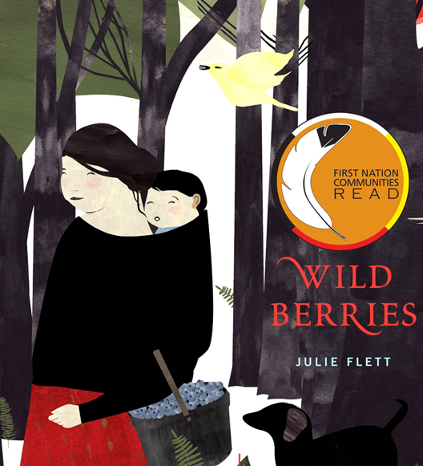
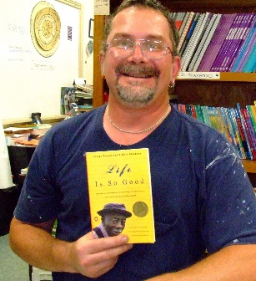
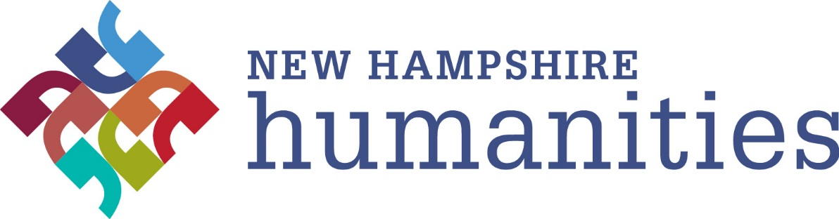

Connections… reading + discussing + connecting with one another
and ideas through stories

Dates:

Times:

Contact:

Books:

New Hampshire Humanities, 117 Pleasant St, Concord, NH 03301
603-224-4071 www.nhhumanities.org

