Connections Reading List 2020-21

Connections is New Hampshire Humanities’ book discussion program for life-long learners. We bring content-rich, beautifully illustrated children’s, YA, and adult literature to adult literacy partners including Adult Basic Education, ESOL and Hi-set classes, Family Connections Center programs within the Department of Corrections and classes for developmentally disabled adults. Students read from one to four books over four meetings. Trained facilitators bring in creative activities and guide students through discussions on humanities themes such as History, Art as Power, The Right to Be, and Our Earth. Students connect to their own stories and ideas, learn from each other, and create a vibrant community of readers.
We organize the books around themes; readers experience deep satisfaction from recognizing patterns of thoughts and ideas in books that at first might seem unrelated. Finding connections among people’s stories, whether it be around ideas of liberty or about what we want to eat, inspires discussion and figuring out who we are as individuals. You can also mix and match the books to create new themes. This list is always a work in progress as facilitators and teachers discover & recommend new books.
ESOL Reading levels are noted for the books. The levels include:
- Literacy+ – for students who are learning how to find objects on a page and are beginning to recognize letters and a few words. (Can also be used with higher ability students)
- Beginner+ – for students who are building vocabulary, have a solid grasp of phonetics and can discuss the story and relate it to their own lives. (Can also be used with lower or higher ability students)
- Intermediate+ – for students who can read a picture book and often middle school level chapter book, understand the meaning of the text as they move forward without needing to identify every word and have discussions about themes and ideas. (Can also be used with lower or higher ability students)
- Advanced – for students who can read newspapers, young adult-level materials, short chapter books and novels and some adult fiction and nonfiction, who are adept at using dictionaries and digital translators, and have higher level discussions about themes.
Many of the higher-level picture books on the list are made accessible to early readers by virtue of their detailed illustrations. Where the text may be out of reach for some of your students, the illustrations can tell the tale. Likewise, a more advanced class often benefits from reading an illustrated book, as it can enhance their understanding of the plot and theme. If you select a book for your class that is available only in hardback, we ask you to select a maximum of two other books that are available in paperback.
For more information on these titles, please check your public library or go to the publisher’s or bookseller’s website where you can often look inside a book and get a better sense of the appropriateness of the match to your class.
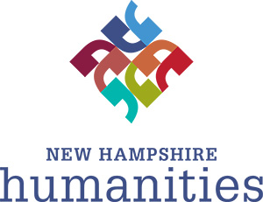

Table of Contents
JOY
CULTURES SIDE BY SIDE
DESCRIBING THE WORLD
WORDLESS PICTURE BOOKS
THE POWER OF ONE
ANIMALS MAKE US HUMAN
TELLING FAMILY STORIES

HUMANITIES AND THE ENVIRONMENT
COMING TO AMERICA
THE RIGHT TO BE
HOW WOMEN WON THE VOTE
WHAT DOES DEMOCRACY LOOK LIKE?
LIBERTY AND THE PURSUIT OF HAPPINESS
U.S. HISTORY
WORK
NEW HAMPSHIRE STORIES
_____________________________________________________________________________________________________________
FAMILIES AROUND THE WORLD
FOLKTALES
JOURNEYS
ART AS POWER

JOY
Discussion Questions: What is joy? How do people find joy in different ways? What factors influence how we find joy and our passions?
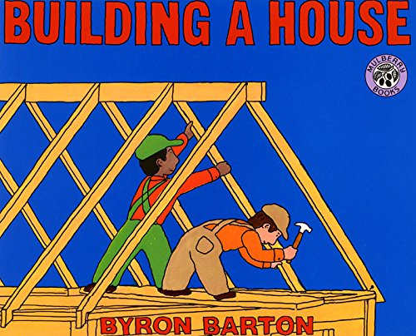 | Building a House by Byron Barton  Literacy +  Skills of carpenters, painters, bricklayers and more are shown as they build a house in the U.S.  Click HERE to preview! | 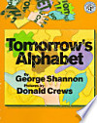 | Tomorrow’s Alphabet by George Shannon Literacy+  A highly creative combination of letters and watercolor paintings that demonstrate where things come from.  Click HERE to preview!
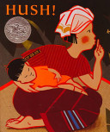 | Hush! A Thai Lullaby by Minfong Ho, Literacy + Read a Thai lullaby and perhaps share lullabies sung in participants’ families and cultures.  Click HERE to preview! | 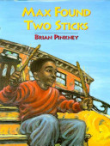 | Max Found Two Sticks by Brian Pinkney  Literacy+  The joy of making music  Click HERE to preview!
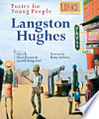 | My People by Langston Hughes, photos by Charles R. Smith  Beginner + Hughes’ poem is accompanied by portraits. The book invites discussion about family, community, culture, love. Single word or phrase on each page.  Click HERE to preview! | 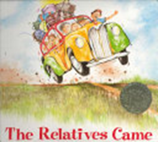 | The Relatives Came by Cynthia Rylant  Beginner+  The joy of company coming  Click HERE to preview!
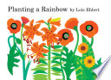 | Planting a Rainbow by Lois Ehlert Literacy + Ehlert's bold collages show bulbs, seeds, and seedlings, and a garden's growth  Click HERE to preview!

CULTURE SIDE BY SIDE
Discussion Questions: What is culture? How are cultures similar or different? Have you ever felt caught between two cultures? How does culture affect our understanding of the world around us?
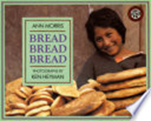 | Bread, Bread, Bread by Ann Morris, photos by Ken Heyman  Literacy + Explores the many traditions of bread around the world  Click HERE to preview! | 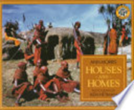 | Houses and Homes by Ann Morris, photos by Ken Heyman  Literacy+  Photos and spare text about houses around the world.  Click HERE to preview!
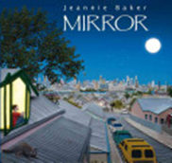 | Mirror by Jeannie Baker  Literacy +  Two cultures (Australia and Morocco) and two stories, with threads of the same story. | NEW! 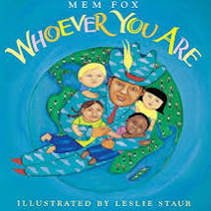 | Whoever You Are by Mem Fox  Literacy +  Every day all over the world, children are laughing and crying, playing and learning, eating and sleeping. They may not look the same. They may not speak the same language. Their lives may be quite different. But inside, they are all alike.  Click HERE to preview!

DESCRIBING THE WORLD
Discussion Questions: How do we learn? What can our natural world teach us? How do stories educate societies? How can we connect to each other through language?
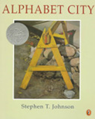 | Alphabet City by Stephen T. Johnson  Literacy +  An alphabet book about finding the shape of English letters in the world around us.  Click HERE to preview! | 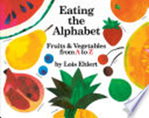 | Eating the Alphabet by Lois Ehlert  Literacy +  An alphabet book of the harvest of the garden.  Click HERE to preview!
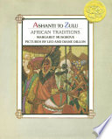 | Ashanti to Zulu: African Traditions by Margaret Musgrove, illus. by Leo and Diane Dillon  Literacy +  An alphabet book of African culture that is also a Caldecott Medal winner for picture book art  Click HERE to preview! | 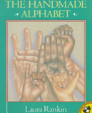 | The Handmade Alphabet by Laura Rankin  Literacy +  An alphabet book in American sign language.  Click HERE to preview!
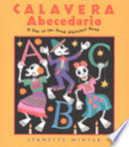 | Calavera Abecedario: A Day of the Dead Alphabet Book by Jeanette Winter  Literacy +  An alphabet book about the Mexican tradition of the celebration of ancestors.  Click HERE to preview! | 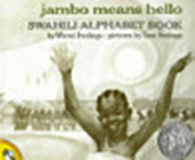 | Jambo Means Hello by Muriel Feelings, illus. by Tom Feelings  Literacy +  An alphabet book in Swahili.  Click HERE to preview!

WORDLESS PICTURE BOOKS
Discussion Questions: How can a picture tell a story? What can we learn from pictures and images? Are pictures a universal language?
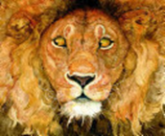 | The Lion and the Mouse by Jerry Pinkney Literacy +  Combines the power of the storytelling with the sheer beauty of the drawings.  Click HERE to preview! | 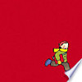 | The Red Book by Barbara Lehman  Beginner +  “Lehman’s story captures the magical possibility that exists every time readers open a book.” School Library Journal  Click HERE to preview!
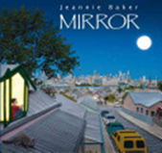 | Mirror by Jeannie Baker  Literacy + Two families living their daily lives are portrayed in pages side by side, one family from Morocco, one family from Australia. | 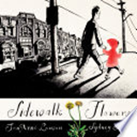 | Sidewalk Flowers By JonArno Lawson  Literacy +  “Bright spots of joy and comfort" in a walk in the city with its flowers.  Click HERE to preview!
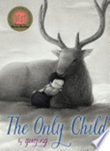 | The Only Child by Guojing  Intermediate +  This story about growing up an only child in China is gripping and a complete short story in length.  Click HERE to preview! | 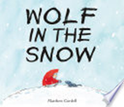 | Wolf in the Snow by Matthew Cordell  Literacy +  A story of kindness overcoming fear, a reversal of the classic Little Red Riding Hood.  Click HERE to preview!

THE POWER OF ONE

Nobel Peace Prize Winners in Picture Book Biographies

Discussion Questions: Can one person make a difference in the world? How? What qualities must they possess? What factors contribute to an individual making positive change?
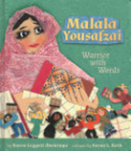 | Malala Yousafzai, Warrior with Words by Karen Leggett Abouraya, illus. by L.C. Wheatley  Beginner+  The story of the Pakistani girl's fight for the right of girls to go to school is told in brief scenes and collage art.  Click HERE to preview! | 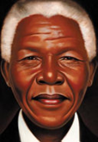 | Nelson Mandela by Kadir Nelson  Beginner+  In spare language and dramatic portraits and landscapes, Kadir Nelson brings South Africa's first black head of state to life.  Click HERE to preview!
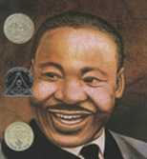 | Martin’s Big Words: The Life of Dr. Martin Luther King, Jr. by Doreen Rappaport, illus. by Bryan Collier  Beginner+  Biography of Martin Luther King illustrated with Collier’s watercolor and collage art.  Click HERE to preview! | 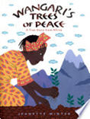 | Wangari’s Trees of Peace by Jeannette Winter  Beginner+  A story of the Kenyan Nobel-Prize-winning environmental activist in an edition that is short and easy to read.  Click HERE to preview!

ANIMALS MAKE US HUMANS
Discussion Questions: What makes us human? What similarities do animals and humans share? Can humans learn anything from animals? What makes someone a friend?
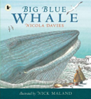 | Big Blue Whale by Nicola Davies. Nonfiction.  Beginner+  An award-winning nonfiction picture book about the largest known animal. | 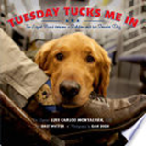 | Tuesday Tucks Me In: The Loyal Bond Between a Soldier and a Service Dog by Luis Carlos Montalvan.  Picture book nonfiction – Beginner +  A simply told picture-book version of this story of a military veteran and his service dog.  Click HERE to preview!
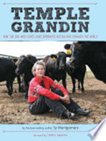 | Temple Grandin: How the Girl Who Loved Cows Embraced Autism and Changed the World by Sy Montgomery.  Biography. Advanced  The story of Temple Grandin and her experience of autism.  Click HERE to preview! | 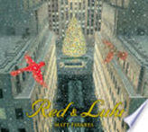 | Red and Lulu by Matt Tavares.  Picture book – Beginner+  A story of New York City in the holidays and two cardinals who are separated and search for each other. Commended for its visual storytelling.  Click HERE to preview!
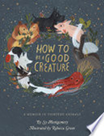 | How to Be a Good Creature: A Memoir in Thirteen Animals by Sy Montgomery,  Memoir. Advanced  Short personal essays that can be read in the whole or by singling out individual pieces. “A truly beautiful book about life, family, loss, and love.” Temple Grandin, author of Animals Make Us Human.  Click HERE to preview! | NEW!  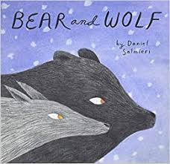 | Bear and Wolf by Daniel Salmieri  Picture book- Beginner+  Bear and Wolf become unlikely companions one winter's evening when they discover each other out walking in the falling snow; they are young and curious, slipping easily into friendship as they amble along together, seeing new details in the snowy forest.  Click HERE to preview!

TELLING FAMILY STORIES
Discussion Questions: What is family? What and how do families teach us? How can families shape our life experiences and opportunities? How can language define and connect families?
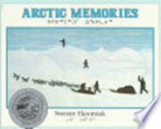 | Arctic Memories by Normee Ekoomiaka (bilingual Inuit and English)  Picture book – Beginner+  The author describes the food, the clothes, the games, the language of his childhood in Alaska.  Click HERE to preview! | 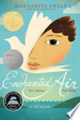 | Enchanted Air: Two Cultures, Two Wings by Margarita Engle  Memoir in verse, Advanced  Margarita Engle tells of growing up as a child in two cultures, Cuba and the U.S., during the Cold War. It begins with "Four Years Before I Existed," which could lead to stories and writing with the prompt, "Imagine the day that your parents met."  Click HERE to preview!
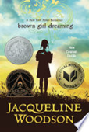 | Brown Girl Dreaming by Jacqueline Woodson  Memoir in verse – Advanced  Woodson, a former National Ambassador for Young People's Literature, writes a stunning biography in verse of growing up African American with dreams of being a writer.  Click HERE to preview! | 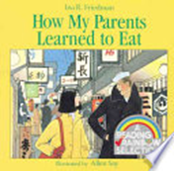 | How My Parents Learned to Eat by Ina Freidman, Illus. by Allen Say Picture book. Beginner+  In Japan, a Japanese woman and Anglo-American man meet and learn to understand each other, especially through culinary traditions. This is a humorous yet realistic picture of two people from different cultures getting to know each other and falling in love.  Click HERE to preview!
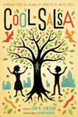 | Cool Salsa, edited by Lori M. Carlson (bilingual English and Spanish)  poetry collection – Intermediate+  Bilingual poems on growing up Latino in the United States | 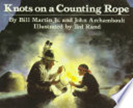 | Knots on a Counting Rope, by Bill Martin, Jr. and John Archambault, illus. by Ted Rand  Picture book. Intermediate +  A grandfather empowers his grandson with identity and memories, all in dialogue and pictures. Wonderful to read aloud in two voices.  Click HERE to preview!
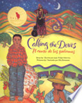 | Calling the Doves by Juan Felipe Herrera (bilingual English and Spanish)  Picture book memoir – Beginner+  Juan Felipe's fond memories of his mother and father and his life on the road as the child of migrant parents.  Click HERE to Preview! | 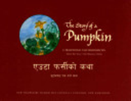 | The Story of a Pumpkin, by Hari Tiwari, illus. by Dal Rai (bilingual Nepali and English)  Intermediate+  A childless couple become the parents of a young pumpkin and all goes well until the pumpkin goes in search of a wife. A bilingual folktale from Bhutan in English and Nepali.
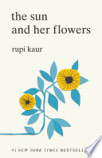 | The Sun and Her Flowers by Rupi Kaur  Poetry collection – Advanced  A young Indian Canadian woman’s very accessible poems about life, love, and identity.  Click HERE to preview!

HUMANITIES AND THE ENVIRONMENT

Discussion Questions: In what ways has our environment changed over time? How do humans affect the environment and how does the environment affect humans? How can we care for and protect our environment?
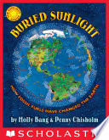 | Buried Sunlight by Molly Bang and Penny Chisholm  Nonfiction Picture Book – Intermediate +  Molly Bang, creator of many classic stories, has also created books to illustrate climate change. This book, in Bangs’ Sunlight series, illuminates how fossil fuels have changed the earth.  Click HERE to Preview! |  | Wangari’s Trees of Peace by Jeannette Winter  Beginner+  A story of the Kenyan Nobel-Prize-winning environmental activist in an edition that is short and easy to read.  Click HERE to preview!
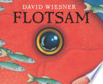 | Flotsam by David Wiesner (wordless) * Wordless picture book. Literacy + A boy finds an underwater camera washed up on the beach, develops the film, and discovers worlds beyond worlds.  Click HERE to Preview! | NEW!  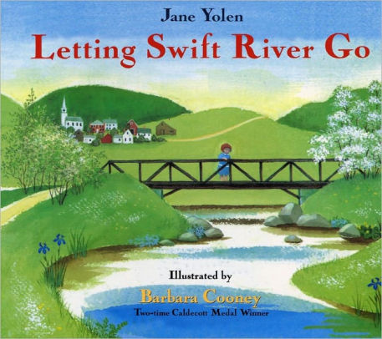 | Letting Swift River Go by Jane Yolen  Intermediate +  Relates Sally Jane's experience of changing times in rural America, as she lives through the drowning of the Swift River towns in western Massachusetts to form the Quabbin Reservoir.  Click HERE to preview!
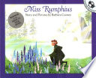 | Miss Rumphius by Barbara Cooney Beginner +  Called by a reviewer, “an oasis of calm and beauty.” Themes include the natural world, wisdom, New England, and restoring our earth. Based on an actual “Lupine Lady” in Maine.  Click HERE to preview! | NEW!  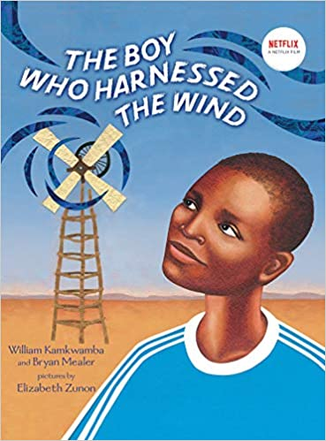 | The Boy Who Harnessed The Wind by William Kamkwamba & Bryan Mealer  Beginner +  When fourteen-year-old William Kamkwamba's Malawi village was hit by a drought, everyone's crops began to fail. Without enough money for food, let alone school, William spent his days in the library . . . and figured out how to bring electricity to his village. Persevering against the odds, William built a functioning windmill out of junkyard scraps, and thus became the local hero who harnessed the wind.  Click HERE to preview!
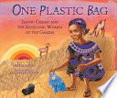 | One Plastic Bag: Isatou Ceesay and the Recycling Women of the Gambia by Miranda Paul, illus. by Elizabeth Zunon Picture book – Beginner+  A tale of growing ecological awareness and grassroots environment activism led by a group of women.  Click HERE to preview!

THE RIGHT TO BE
Discussion Questions: How are our identities shaped by our individual experiences? What is the role of tradition in building our awareness of ourselves? Is freedom a right?
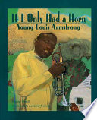 | If I Only Had a Horn, by Roxanne Orgill, illustrated by Leonard Jenkins.  Picture book biography – Beginner +  An illustrated biography of Louis Armstrong when he was a boy and longed to play music.  Click HERE to preview! |  | Brown Girl Dreaming, by Jacqueline Woodson,  Memoir in verse. Advanced  Click HERE to preview!
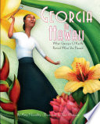 | Georgia in Hawaii by Amy Novesky, illustrated by Yuyi Morales,  Picture book biography – Beginner +  An illustrated biography of Georgia O’Keeffe on assignment.  Click HERE to preview! | 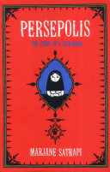 | Persepolis by Marjane Satrapi,  Advanced  A graphic memoir of growing up in Iran during the revolution.  Click HERE to preview!
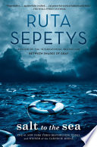 | Salt to the Sea by Ruta Sepetys  Nonfiction – Advanced  “In 1945, World War II is drawing to a close in East Prussia and thousands of refugees are on a desperate trek toward freedom…A tribute to the people of Lithuania, Poland, and East Prussia.” Publisher's summary  Click HERE to preview! | 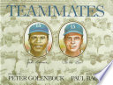 | Teammates by Peter Golenbock, illus. by Paul Bacon  Picture book biography - Intermediate + Biography of Jackie Robinson with photos and illustrations.  Click HERE to preview!

HOW WOMEN WON THE VOTE:
Discussion Questions: Why were women not allowed to vote until the 20th century? What strategies did women use to win the right to vote? Which were most successful? Why did only some women gain the right to vote with the ratification of the 19th Amendment? Is equality essential?
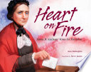 | Heart on Fire: Susan B. Anthony Votes for President by Ann Malaspina, illus by Steve James. Picture book biography – Beginner+  Click HERE to preview! | 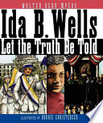 | Ida B. Wells: Let the Truth Be Told by Walter Dean Myers, illus. by Bonnie Christensen.  Picture book biography – Beginner +
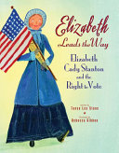 | Elizabeth Leads the Way: Elizabeth Cady Stanton and the Right to Vote by Tanya Lee Stone  Picture book biography Beginner +  Click HERE to preview! | 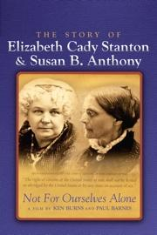 | Not For Ourselves Alone: The Story of Elizabeth Cady Stanton & Susan B. Anthony,  a documentary by Ken Burns  Click HERE to preview documentary!
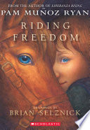 | Riding Freedom by Pam Munoz Ryan.  Novel – Advanced  Click HERE to preview! | NEW!  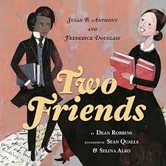 | Two Friends: Susan B. Anthony and Frederick Douglass by Dean Robbins  Beginner +  Susan B. Anthony and Frederick Douglass, recount their similar stories fighting to win rights for women and African Americans  Click HERE to preview!

You’ll see many more books about women gaining the right to vote with notations about reading levels here: https://www.amightygirl.com/blog?p=11827

WHAT DOES DEMOCRACY LOOK LIKE?
Discussion Questions: What should democracy look like? Who gets to participate in a democracy? What barriers have limited people’s access to democratic institutions? Is equality essential?
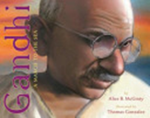 | Ghandi: A March to the Sea by Alice B. McGinty, illus. by Thomas Gonzalez  Intermediate +  Mohandas Gandhi protests British rule in India in a 1930 act of civil disobedience.  Click HERE to preview! | 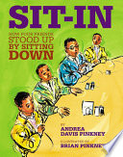 | Sit – In: How Four Friends Stood Up by Sitting Down by Andrea Pinkney, illus by Brian Pinkney  Intermediate +  A story of the famous Greensboro, NC sit-in at the Woolworth’s lunch counter that launched thousands of sit-ins across the country to bring about an end to segregation.  Click HERE to preview!
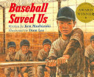 | Baseball Saved Us by Ken Mochizuki, illus. by Dom Lee  Picture book – Intermediate +  During World War II, a young Japanese-American boy and his family are sent to an internment camp after the attack on Pearl Harbor. Despondent in their desolate surroundings, father and son pull the camp together to build a baseball diamond and form a league.  Click HERE to preview! | 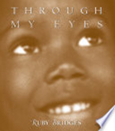 | Through My Eyes: The Autobiography of Ruby Bridges by Ruby Bridges Intermediate+ A memoir from the first African American pupil to attend a formerly segregated school in New Orleans in 1960. Excellent prompt for discussion about civil rights and segregation. Click HERE to preview!
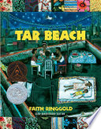 | Tar Beach by Faith Ringgold  Picture book – Beginner +  Two children’s imaginations re-create their world. “There is an air of triumph in Ms. Ringgold’s vision.” New York Times  Click HERE to preview!

COMING TO AMERICA
Discussion Questions: Why do people leave their native country? What difficulties do they face in their journey? How easy is it to get used to a new culture? Can an immigrant be at home in America without losing his or her identity?
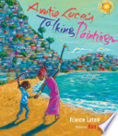 | Auntie Luce's Talking Paintings by Francie Latour, illus. by Ken Daley  Picture book – Beginner +  A child visits her auntie in Haiti, the country her family left to come to America. Through the aunts paintings, the child learns who she is and about her home country.  Click HERE to preview! | 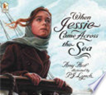 | When Jessie Came Across the Sea by Amy Hest, illus. by P.J. Lynch.  Intermediate+  Jessie emigrates from Eastern Europe to New York City in the early 1900s.  Click HERE to preview!
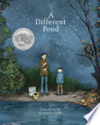 | A Different Pond by Bao Phi  Picture book - Beginner +  A boy cherishes the ritual of fishing with his father.  Click HERE to preview! | 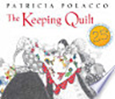 | The Keeping Quilt by Patricia Polacco.  Picture book – Beginner +  Polacco’s classic story of Russian immigrants to the U.S.  Click HERE to preview!

COMING TO AMERICA (CONTINUED)

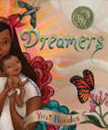 | Dreamers by Yuyi Morales  Picture book – Literacy +  A Mexican-American mom and her little boy learn English and a love of books when they are welcomed at the public library.  Click HERE to preview! | 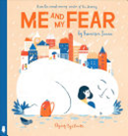 | Me and My Fear by Francesca Sanna  Picture book – Beginner +  Sanna shows in images how a young migrant learns to handle her fear.  Click HERE to preview!
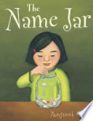 | The Name Jar by Yangsook Choi.  Picture book – Beginner +  A small girl must decide what name she will use in America.  Click HERE to preview! | 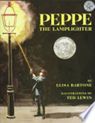 | Peppe the Lamplighter by Elisa Bartone, illus. by Ted Lewin Beginner+ An immigrant family seeks work and self respect in New York City’s Little Italy.  Click HERE to preview!

LIBERTY AND THE PURSUIT OF HAPPINESS
Discussion Questions: What is the meaning of freedom? What responsibilities do we each have to uphold it? How has US History either supported or conflicted with their founding ideas of life, liberty, and the pursuit of happiness?
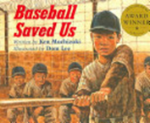 | Baseball Saved Us by Ken Mochizuki, illus by Dom Lee  Intermediate+  During World War II, a young Japanese-American boy and his family are sent to an internment camp after the attack on Pearl Harbor. Despondent in their desolate surroundings, father and son pull the camp together to build a baseball diamond and form a league.  Click HERE to preview! |  | 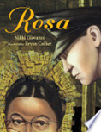 | Rosa by Nikki Giovanni, illus. by Bryan Collier Intermediate+ This biography of Rosa Parks tells the story of simple act of courage that launched the Montgomery Bus Boycott.  Click HERE to preview!
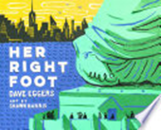 | Her Right Foot by Dave Eggers, illus. by Shawn Harris  Picture book - Beginner +  “She’s in New York./ She’s holding a torch./ And she’s in mid-stride…” Eggars on the building and the meaning of the Statue of Liberty.  Click HERE to preview! |  | 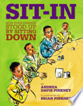 | Sit – In: How Four Friends Stood Up by Sitting Down by Andrea Pinkney, illus by Brian Pinkney  Intermediate+  A story of the famous Greensboro, NC sit-in at the Woolworth’s lunch counter that launched thousands of sit-ins across the country to bring about an end to segregation.  Click HERE to preview!
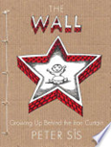 | The Wall: Growing up Behind the Iron Curtain by Peter Sis.  Graphic memoir - Advanced  Sis writes history from his own memories of growing up in Czechoslovakia during the Cold War  Click HERE to preview! | NEW!  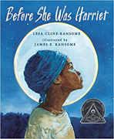 |  |  | Before She Was Harriet by Lisa Cline-Ransome  Beginner+  We know her today as Harriet Tubman, but in her lifetime she was called by many names.  Click HERE to preview!

HISTORY OF THE US
Discussion Questions: What is history? Who determines history? Are there voices in history that have been left out? Whose & Why? Can history be made by ordinary people? How is history changed by acceptance or rejection of new ideas and values?
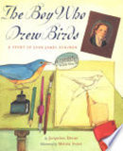 | The Boy Who Drew Birds: A Story of John James Audubon by Jacqueline Davies, illus. by Melissa Sweet. Intermediate+ A story of the great student and painter of birds. Nonfiction, biography.  Click HERE to Preview! | 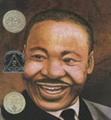 | Martin’s Big Words: The Life of Dr. Martin Luther King, Jr. by Doreen Rappaport, illus. by Bryan Collier Beginner +  Biography of Martin Luther King illustrated with Collier’s water color and collage art. Biography.  Click HERE to preview!
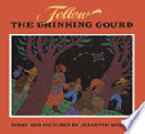 | Follow the Drinking Gourd by Jeanette Winter Beginner+  An imaginative story of the Underground Railroad.  Click HERE to Preview! | 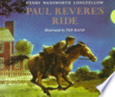 | Midnight Ride of Paul Revere by Henry Wadsworth Longfellow, illus. by Ted Rand Literacy + An illustrated telling of the classic poem. Click HERE to preview!
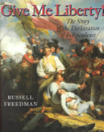 | Give Me Liberty! The Story of the Declaration of Independence by Russell Freedman  Advanced “Freedman takes a crucial moment in American history and imbues it with living grace and powerful tension.” | 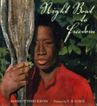 | Night Boat to Freedom by Margot Theis Raven  Intermediate+  Award-winning illustrated book based on slave narratives collected by the Federal Writers’ Project.  Click HERE to preview!
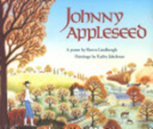 | Johnny Appleseed by Reeve Lindbergh Beginner+  Here, this classic tale is told in verse, with detailed illustrations.  Click HERE to preview! | 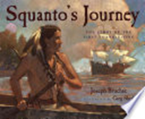 | Squanto’s Journey by Joseph Bruchac, illus. by Greg Shed Intermediate+ A story of the first Thanksgiving.  Click HERE to preview!
 | Rosa by Nikki Giovanni, illus. by Bryan Collier Intermediate+ Biography of Rosa Parks  Click HERE to preview! | 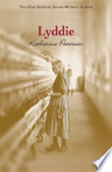 | Lyddie by Katherine Paterson Advanced - Novel  Set in 1843, a girl leaves her family’s failing farm in Vermont to work in the textile mills of Lowell, Massachusetts. 192 pages.  Click HERE to preview!
NEW!  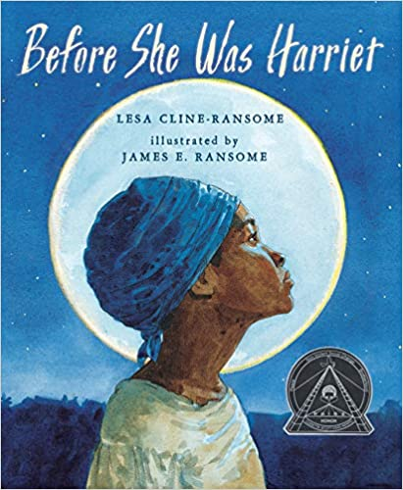 | Before She Was Harriet by Lisa Cline-Ransome  Beginner+  We know her today as Harriet Tubman, but in her lifetime she was called by many names.  Click HERE to preview!

WORK
Discussion Questions: What is work? How has worked changed throughout history? How can work impact our life and families?
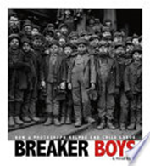 | Breaker Boys by Michael Burgan with photographs by Lewis Hine  Intermediate + This book tells the story of young boys who sorted coal in dusty, loud, and dangerous conditions. Many of these breaker boys worked 10 hours a day, six days a week all for as little as 45 cents a day. Child labor was common in the United States in the 19th century. The photographs of Lewis Hine and others bring the harsh working conditions to light.  Click HERE to preview! | 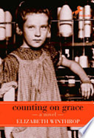 | Counting on Grace by Elizabeth Winthrop  Intermediate+ 1910: At 12, Grace and her best friend Arthur must leave school and go to work as a “doffers” on their mothers’ looms in the mill. Horrified by the working conditions and the very young children they see, they write a secret letter to the Child Labor Board about underage children working in Pownal, Vermont. What happens next changes her sense of herself, her future, and her family’s future.  Click HERE to preview!
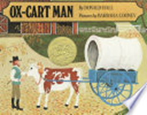 | Ox-Cart Man by Donald Hall, illus. by Barbara Cooney Literacy +  Hall’s poem with Cooney’s primitive paintings follow the New England seasons through the life of a mid-19th century farmer.  Click HERE to preview! |  | Lyddie by Katherine Paterson Advanced - Novel  Set in 1843, a girl leaves her family’s failing farm in Vermont to work in the textile mills of Lowell, Massachusetts. 192 pages.  Click HERE to preview!
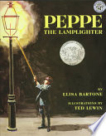 | Peppe the Lamplighter by Elisa Bartone, illus. by Ted Lewin Beginner +  An immigrant family seeks work and self respect in New York City’s Little Italy.  Click HERE to preview! | 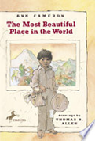 | The Most Beautiful Place in the World by Ann Cameron  Intermediate+  In a small, first chapter book, a Guatemalan grandmother and grandson make the boy’s dream to go to school come true. Cameron is a master of spare, emotionally true stories and presents social issues that lead to rich discussions. Themes include education, poverty and child labor.  Click HERE to preview!
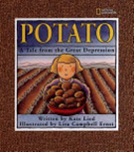 | Potato: A Tale from the Great Depression by Kate Lied, illus. by Lisa Ernst Beginner+  When Dorothy's father loses his job and cannot find another the family borrows a car and sets off for Idaho where jobs digging potatoes can be found. The author was eight years old when she wrote this family story told to her by her aunt. | 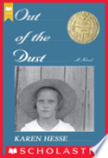 | Out Of The Dust by Karen Hess Advanced This gripping story, written in sparse first-person, free-verse poems, is the compelling tale of Billie Jo's struggle to survive during the dust bowl years of the Depression. Newbery Medal  Click HERE to preview!

WORK (Continued)

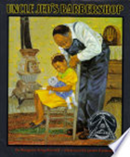 | Uncle Jed’s Barbershop by Margaree King Mitchell  Beginner+  As the only black barber in a county of sharecroppers during the 1920s, Uncle Jed traveled for miles to tend to his customers and dreamed of someday opening his own shop.  Click HERE to preview! | 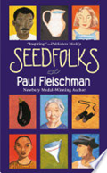 | Seedfolks by Paul Fleischman, illus. by Judy Pedersen Intermediate+ A collection of stories of people from around the world who are now neighbors with a common love – growing things in the ground. “Thirteen voices tell one story of the flowering of a Cleveland vacant lot into a neighborhood garden.” Short novel made up of small stories. 70 pages.

NEW HAMPSHIRE STORIES
Discussion Questions: Why is New Hampshire the way it is today? How has New Hampshire been shaped by many voices? What shapes New Hampshire’s unique identity?
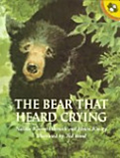 | The Bear That Heard Crying by Natalie Kinsey – Warnock, illus. by Helen Kinsey Intermediate+ Little Sarah Witcher wanders off into the woods and spends a night curled up with a bear! Based on a true NH tale from Colonial times. | 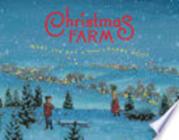 | Christmas Farm by Mary Lyn Ray, illus. by Barry Root  Beginner+ NH writer and conservationist, Mary Lyn Ray has written this story about growing Christmas trees and a unique friendship. Themes include New Hampshire, holidays, Christmas in New England, Planting the Earth.  Click HERE to preview!
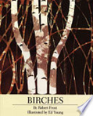 | Birches by Robert Frost, illus. by Ed Young Intermediate+ An illustrated telling of Frost’s classic poem evocative of NH settings.  Click HERE to preview! |  | Ox-Cart Man by Donald Hall, illus. by Barbara Cooney Literacy+ Hall’s poem with Cooney’s primitive paintings follow the New England seasons through the life of a mid-19th century farmer.  Click HERE to preview!
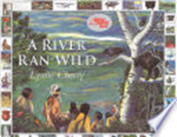 | A River Ran Wild by Lynne Cherry Intermediate+ Modern-day descendants of the Nashua Indians and European settlers were able to combat pollution and restore the beauty of the Nashua River in Massachusetts.  Click HERE to preview! | NEW!  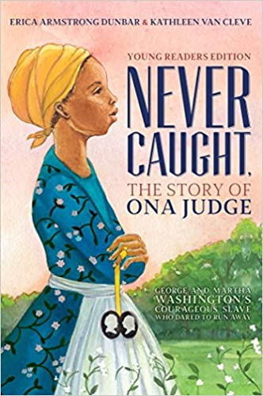 | Never Caught: The Story of Ona Judge by Erica Armstrong Dunbar& Kathleen Van Cleve  Advanced  From her childhood, to her time with the Washingtons and living in the slave quarters, to her escape to New Hampshire, Erica Armstrong Dunbar, along with Kathleen Van Cleve, shares an intimate glimpse into the life of a little-known, but powerful figure in history, and her brave journey as she fled the most powerful couple in the country.  Click HERE to preview!

FAMILIES AROUND THE WORLD
Discussion Questions: What is a family? Who is your family? What do families teach us about ourselves and our place in the world? What responsibilities do families have?
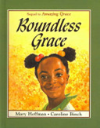 |  | Boundless Grace by Mary Hoffman, illus. by Caroline Binch  Literacy+  A girl and her grandmother travel to Africa where the girl’s father now lives with a new wife.  Click HERE to preview! |  | The Most Beautiful Place in the World by Ann Cameron.  Intermediate+- Chapter book  In a small, first chapter book, a Guatemalan grandmother and grandson make the boy’s dream to go to school come true. Cameron is a master of spare, emotionally true stories and presents social issues that lead to rich discussions. Themes include education, poverty and child labor. 64 pages.  Click HERE to preview!
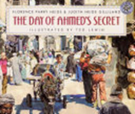 |  | The Day of Ahmed’s Secret by Florence Parry Heide, illus. by Ted Lewin Beginner+ Set in Cairo, the story and illustrations recreate the sound, scent, and images of the city. “Life goes on in the hectic, noisy cities of the world regardless of a day's news and yet, the boundless energy and promise of youth reinforce the ideal that anything is possible. Ahmed's story is a joyful celebration of that spirit.”- School Library Journal. | 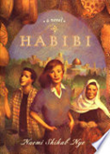 | Habibi by Naomi Shihab Nye  Advanced- Novel  An American girl moves with her family to Palestine and into the Arab heritage of her father’s family in this novel of reaching out across cultures and divides. Themes include cross cultural families and peace - building. 272 pages.  Click HERE to preview!
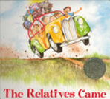 |  | The Relatives Came by Cynthia Rylant, illus. by Stephen Gammell Beginner+ Story of a joyous, summer family party in the American south.  Click HERE to preview! | 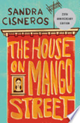 | The House on Mango Street by Sandra Cisneros  Advanced- Novel  Short adult novel in small chapters. Cisneros writes about growing up in a Latino family. Themes include identity, immigrant neighborhoods, home, living in two cultures, courage. 110 pages.
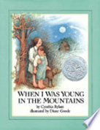 | When I Was Young in the Mountains by Cynthia Rylant, illus. by Diane Goode Literacy+  Memories of growing up in Appalachia. Caldecott Honor  Click HERE to preview!

FOLK TALES
Discussion Questions: Why do cultures around the world have myths and folktales? What can we learn about a culture and ourselves through these stories? What stories does your family tell over and over?
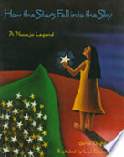 | How the Stars Fell into the Sky, a Navajo Legend retold by Jerry Oughton, illus by Lisa Desimini Beginner +  What is the best place to write the laws for all to see? An enchanting tale with stunning illustrations.  Click HERE to preview! | 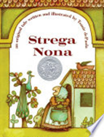 | Strega Nona, by Tomie De Paola Award-winning NH Author/Illustrator and featured speaker at the Connections 2015 family literacy event  Beginner+  A "Grandma Witch," a magic pot and a curious, hungry attendant make for disaster! This classic tale has many counterparts from around the world.  Click HERE to preview!
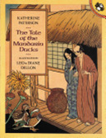 | The Tale of the Mandarin Ducks, by Katherine Paterson  Intermediate+  A beautiful mandarin duck is captured and caged by a greedy lord who wants to show off the bird's magnificent plumage. When the kitchen maid releases the bird against her lord's command, she and the one-eyed servant, Shozo, are sentenced to death. The grateful bird intends to return their kindness, but can he outsmart the cruel lord?  Click HERE to preview! |  | The Story of a Pumpkin, by Hari Tiwari, illus. by Dal Rai NH Author and illustrator, published by the New Hampshire Humanities. Intermediate+ A childless couple become the parents of a young pumpkin and all goes well until the pumpkin goes in search of a wife. A bilingual folktale from Bhutan in English and Nepali.

Folktale Selections from the International Children’s Digital Library www.childrenslibrary.org The International Children’s Digital Library is a free online library for children and other learners around the world. The library is comprised of scanned images of actual books (many are out of print) and the illustrations are stunning. Many of the books have text in multiple languages. A projector and large screen or blank wall will be necessary for viewing. These books cannot be downloaded, but can be viewed as many times as you wish. Students can learn how to access the site and read a book at home with their children in English or their native language. Connections facilitators will plan discussion topics, activities and supplementary materials as usual. There can be many advantages to viewing and reading a story together in this way.
Digital Picture Books from ICDL
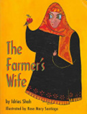 | The Farmer’s Wife, by Idries Shah, illus. by Rosemary Santiago (ICDL) Beginner+ A farmer's wife tries to retrieve an apple from a hole in the ground. Read to learn how she solves her problem. | 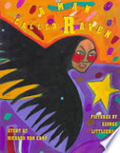 | A Man Called Raven by Richard Van Camp (ICDL) Intermediate+ A mysterious man tells two Indian brothers why they must not hurt the ravens that pester them.  Click HERE to Preview!
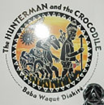 | The Hunterman and the Crocodile by Baba Wague Diakite (ICDL) Beginner +  A hunter and a crocodile take turns being captive and captor in a humorous folktale that teaches the importance of living in harmony with nature and is illustrated with ceramic-tile paintings.

JOURNEYS
Discussion Questions: What is your journey? What are different types of journeys that we take in life? How can different journeys impact or change our lives?
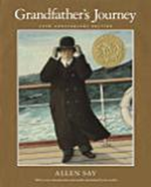 | Grandfather’s Journey by Allen Say Beginner+ A man lives in two cultures, and when he is in one, he yearns for the other.  Click HERE to preview! | 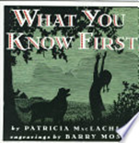 | What You Know First by Patricia MacLachlan, Intermediate + Set in the U.S. during the Depression, the story captures the universal emotions of leaving a place one loves.  Click HERE to preview!
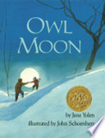 | Owl Moon by Jane Yolen Beginner+  A father and his little girl follow the call of the owl through the woods on a winter night. Poem.  Click HERE to preview! | 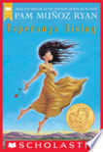 | Esperanza Rising by Pam Muñoz Ryan Intermediate A courageous girl must move from Mexico to work among the farm laborers in California during the Great Depression. 262 pages.  Click HERE to preview!

ART AS POWER
Discussion Questions: What is art? Why do we create art? What can artwork tell us about a culture or society?
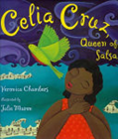 | Celia Cruz by Veronica Chambers, illus. by Julie Maren  Beginner+ The story of the famous Cuban singer and how she becomes the “Queen of Salsa.”  Click HERE to preview! | 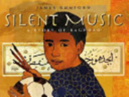 | Silent Music: A Story of Bagdad by James Rumford*  Intermediate+  A boy uses skill at calligraphy to express himself as his country is enveloped in war. Beautiful illustrations.  Click HERE to preview!
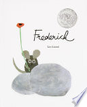 | Frederick by Leo Lionni Literacy+ Frederick the mouse reveals the power of poems.  Click HERE to preview! | 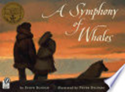 | Symphony of Whales by Steve Schuch, illus. by Peter Sylvada Intermediate +  Whales stranded near the Bering Strait respond to the sounds of classical music and follow the music to the open sea.  Click HERE to preview!
 | The Keeping Quilt by Patricia Polacco Beginner+  From a basket of old clothes, an immigrant mother from Russia makes a quilt and connects her family to home.  Click HERE to preview! | 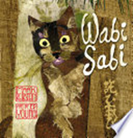 | Wabi Sabi by Mark Reibstein, illus. by Ed Young. Intermediate+  This picture book explores the Japanese idea of wabi sabi - beauty in that which is simple, natural, and imperfect - and haikus, the 17-syllable poem.  Click HERE to preview!
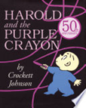 | Harold and the Purple Crayon by Crockett Johnson  Literacy +  Follow Harold’s imagination as he draws his world and walks into it.  Click HERE to preview! | 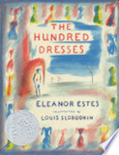 | The Hundred Dresses by Eleanor Estes Chapter book. Intermediate +  A timeless story for all ages about prejudice, personal choice, art, and defining one's own identity. 96 pages  Click HERE to preview!
ART AS POWER (Continued)

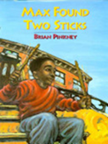 | Max Found Two Sticks by Brian Pinkney Literacy+  A boy finds two sticks and daydreams himself into a world of percussion.  Click HERE to preview!

